For this assignment, you will solve problems based on what you have learned in Chapters: Elementry Programming.

Instructions

- Review the chapters from the book and class notes.
- There are 5 questions in this assignment.

Due Date and Time: August 7, 2019, in class.

Submitting this Assignment

You do not have to submit this assignment. When you have completed solving all questions, show them to the Instructor.

Grading Criteria

There are no marks to this assignment.

Note: Use class JOptionPane/Scanner to take input.

Questions:
- Write a program that displays the following table:

a a^2 a^3
1 1 1
2 4 8
3 9 27
4 16 64

- Write the program which lets the user to enter the interest rate, number of years, and loan amount and computes monthly payment. And, display the monthly payment with the accuracy of two decimal places.

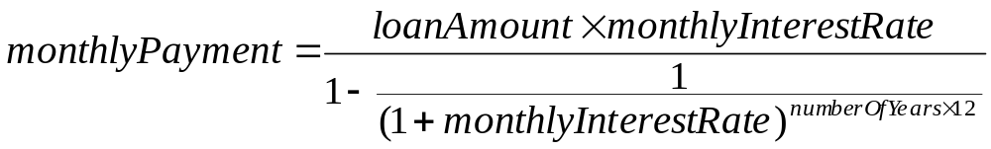

- (Algebra: solve 2 * 2 linear equations) You can use Cramer’s rule to solve the following 2 * 2 system of linear equation:
ax + by = e
cx + dy = f
x = (ed – bf) /(ad – bc)
y = (af – ec)/ (ad – bc)
Write a program that solves the following equation and displays the value for x and y:
3.4x + 50.2y = 44.5
2.1x + .55y = 5.9

- Write a program that displays current time in GMT in the format hour:minute:second such as 1:45:19.
The currentTimeMillis method in the System class returns the current time in milliseconds since the midnight, January 1, 1970 GMT. (1970 was the year when the Unix operating system was formally introduced.) You can use this method to obtain the current time, and then compute the current second, minute, and hour as follows.
(use only arithematic operators to calculate the time)

- Body Mass Index (BMI) is a measure of health on weight. It can be calculated by taking your weight in kilograms and dividing by the square of your height in meters. The interpretation of BMI for people 16 years or older is as follows:
